
I
Letter from Chair

Following the AGM and with effect from 1st April we now have some new committee members. I am really pleased to take on the role of Chairperson for the club. I am always so proud to be a part of West Hull Ladies and I look forward to working with the other committee members. Thank you to all of those who have previously undertaken committee roles, in particular to Antonia, from whom I have taken over the role of Chairperson.

Annual club membership subscriptions are due at the moment so don’t forget to get your payment to Victoria Voase, Club Treasurer. It is £22 for the year and goes towards club funds to provide events such as the AGM, awards and trophies and the popular evening events we held last year. Your subscription also gets you membership of England Athletics which enables you to enter races at a reduced rate. For all those who have already paid their subs, membership of England Athletics has now been paid for this season and you should receive your England Athletics card shortly. For those who have yet to pay, if you submit a cheque don’t forget to write your name on the back for ease of identification.

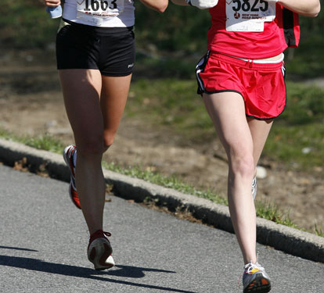
Good luck to everyone who is taking part in the London Marathon on Sunday 25th April, in particular our ladies Antonia, Debbie and Victoria. Training for a marathon is such a huge undertaking and I am always in awe of those who commit their time and effort. We look forward to the results and reading their race reports in next month’s newsletter.

Becca King

Letter from Editor

I can’t decide which fact is the most surprising - a. that I’ve started running, b. that I’ve joined a running club, or c. that I’m the club’s new Newsletter Officer? Either way, all three questions are challenging me to pastures new in my life which is really exciting. What a pleasure it is to be learning so many new things and, from such a fantastic group of ladies. Thank you to everyone who has contributed to this month’s edition.

Amanda C

West Hull Ladies R.R.C.
Next Committee Meeting:

10th May 2010
AGM Reports
26th March 2010

Treasurer Report 2009 -2010

Well reporting financial details is rather boring but here goes!!! As treasurer I look after the club accounts and record all expenditure and incomes, bank money, match the bank statements to the club records and pay suppliers.

The accounts run from 1st March 2009 – 28th February 2010, as we have had no major events this year I would just like to let members know our main source of monies received and what we spend money on.

During this year we have received £1,168.00 in membership fees, received clothing payments totalling £927.75 and we had some miscellaneous income generated from the raffle at last years AGM, we also generally add £1.00 onto buffet when organising sports talks which ensures that if we have a speaker they are provided with food and any excess goes towards club funds, this resulted in an £87.40 going into the account during the year. After sorting out the university fee for our beep tests we also generated £18.50 towards club accounts from this activity as well.

We do always need a cash flow for the club account to enable us to pay out in advance for things, ie Wok deposit, clothing orders, trophies etc. so the little bit extra that goes into the account from miscellaneous areas is very important.

During the year we have paid £325.00 to England Athletics for member fees and club affiliation. £599.26 has been spent on clothing – however please bear in mind that a few weeks prior to the start of this years accounts we had just paid out £609.00 for a clothing order – so we have not made a massive profit on clothing in fact sadly due to us been too trusting we have lost £44.00 on clothing which has gone out but not been paid for by people who no longer run with the club. To overcome this situation arising again it has been agreed that club clothing will only be handed out when payment is received. We also hold a stock of clothing items so there is continual turnover in clothing money.

Additional miscellaneous items that we have spent money on are, stop watches, website set up and hosting, balloons and trophies for last years AGM and flowers for Antonia to celebrate the birth of baby James. Please however do not all go out and have babies as we took a committee decision to send flowers to Antonia due to her spending considerable time acting as Chairperson for the club, so this was a one off!! – Anyone else having babies will get a big ‘well done’!

Money that comes out of the club account is agreed by at least 3 committee members so that not just one person makes decisions on what to spend money on. And just to make this report even more interesting – the other major event with our banking this year was that we changed banks – so we now bank with Barclays which basically makes life a bit easier for me when banking money as I use Barclays for other business.
And keeping the best till last – I’m very happy to report that during the previous year our membership income was £794.00 but as you will have seen from above we have done a lot better with memberships taking in £1168.00 which is a £374.00 increase on the previous year and as there member fees did not increase during this period it obviously means more members. For those of you who may be wondering why the fees total such strange amounts please bear in mind that although most members pay £20.00 for the year, members who join us towards the end of the year pay slightly less, as do second claim members.

Victoria

Training Officer Report 2009-2010

I’ve been training officer for almost 2 years now and have been amazed at how the club as a whole has improved in fitness and strength over that time. This last year, in particular, has been remarkable and the club has grown, not just in fitness and stamina, but in confidence. Many ladies now see no barriers or boundaries to what they can achieve.

The main part of my role is putting together a suitable training schedule which simply acts as a structure to build your fitness on. However, the real source of improvement comes from the positive attitude of you ladies.

The inclusive nature of the club, as a whole, ensures that ladies feel happy to come out to the training sessions, they feel comfortable that there will always be ladies to run with them. For new ladies, a good welcome is the key to quickly feeling confident about club running and after a few weeks of settling in, most begin to push their own boundaries. Many clubs become very segregated with the faster runners forming a clique which makes it difficult for a runner to move up a pace. My hope is that you all keep looking out for each other and if you notice someone could jump up a level, invite them in and pull them along.

However, since this is a training officer report so on to the training and the basis of how it works. This is based on the 3 aspects of training: Speed Work to improve pace, distance to improve stamina and weekly mileage to improve strength.

The weekly mileage is probably the most important part of your training as this is the foundation that you build on. You should aim to run at least 3 times a week and build up to over 15 miles each week.

The distance run is also important, as much as anything else, is the psychological rewards you get from running further. When you run your first 5 mile you will be glowing, when you run your first 10 mile you could faint with pride.

And then there is Speed Work which is the icing on the cake. I put you through long intervals such as the fast mile, as I found that this improved my running more than short sprints.

Hill training is also a great favourite as it works on leg strength as well aerobic capacity.

Finally, a really important bit, I know that lots of ladies cross train now and this winter we have seen fewer injuries than the last ... which may be related. A cross training session is anything active which is not running ... cycling, swimming, gym, pilates, netball, pram pushing ....

From what I have seen, feedback about your running is important so that you know you are getting better. You get 3 training emails each week and ladies seem to enjoy reading who was out and what they got up to (maybe we are all just nosey).
More quantifiable feedback is available from the West Park Mile and Pearson Park KM times. You can see how you are improving – it says it in numbers.
Races are another great way of seeing how much you are improving and the WHL 10K Series shows in percentage terms how much faster your 10K race has become.

In return, feedback from you is really important so please can you put comments down on the feedback form which is doing the rounds. It’s your club so have your say.

It’s been a very positive year and it’s been a pleasure to be training officer. I hope you all have some great races this year and all improve your running – but most of all I hope you enjoy your running because if you do, everything else falls into place.

Amanda

Racing Officer Report 2009 – 2010

I have been the Racing Officer for West Hull Ladies since October and I enjoy every minute of it!! My role is to keep all you lovely ladies up-to-date with all the latest race news and information via the training emails, website, race file and the monthly newsletters. You all keep me on my toes by asking me about races when we are out running…my only ‘problem’ is I find out about the races for the club and get signed up myself as I feel I need to ‘experience’ the race so I can tell others about it for the next time around!

For those who I haven’t had the pleasure of running with yet, I thought I would just tell you a little bit about me and where my enthusiasm for running/racing comes from. A year ago, running wasn’t even part of my vocabulary never mind my life. All that changed last April as I embarked on my weight loss journey and a ‘Couch to 5K’ training plan so I could physically attempt to run around the Race For Life route in Hull…I then continued to go out running and ran my first 10K in August before joining West Hull Ladies 2 weeks later. My ‘mission’ when I joined was to get myself fit enough to run the Humber Bridge Half in a year’s time…

Since joining the club I have run six races as a West Hull Lady, including my first half marathon in January(!) and two 10 milers. I thoroughly enjoyed these ‘experiences’…once I’d finished them! I’m already signed up for 3 more half marathons this year – Edinburgh, Humber Bridge (yes this will be my third NOT first) and a place through the early ballot for the Great North Run.
I am inspired by the number of ladies who have signed up for races over the last few months. Race days are brilliant especially with the support of each other to get you around the course and cheer you in at the end. I’m getting quite excited about the number of ladies who are going to be running the Beverley 10K in May – 18 at the last count. Is this a record number of entries for our club for one race? Other clubs do notice and comment on our presence at the start of a race…and during particularly when we run past them!

Happy racing and please get in touch via the West Hull Ladies email address especially if you are entering a race as you never know who you could be encouraging to take that first step across the start line…

Karen S

Newsletter Editor Report 2009 – 2010

Each newsletter contains regular contributions from the Chair, Training Officer and Racing Officer. It’s not easy to be inspiring on a regular basis – but somehow they manage it. During the past year both Victoria and Kirstie Skelton have volunteered to become regular contributors to the newsletter and their recipes and Muscle of the Month sections are mouth-watering and informative respectively. I feel that the best part of the newsletter is our race write-ups section so all contributions are gratefully received and much anticipated.

I have been privileged to be the club newsletter editor for over a year but feel it is time for me to stand down and AmandaC has kindly agreed to take over the role (subject to ratification at the AGM). I hope you will be as positive towards her as you have all been towards me.

Many thanks for all your help.
Ruth

Muscle of the Month: Piriformis

Where is it? It attaches to the inside of our sacrum at the bottom of the spine and then passes downwards and outwards to attach to the bony part of the top of the thigh one, on the outside of our thigh.
What is it? Piriformis is a hip rotator – it turns the hip outwards. Given its location, it is often thought of as a gluteal muscle.

What does it do? As mentioned above, it is a hip rotator, so turns the hip / thigh outwards. It also helps to stabilise the head of the femur (thigh bone) in its socket.
How does it get injured? This muscle gets injured / very tight through overuse and also through a lot of sitting down. I always test my patients to see whether there is any tenderness in piriformis and any corresponding restriction in hip rotation and I often find there to be a problem here.
How can piriformis injuries be treated? I treat piriformis injuries through deep muscle belly pressure, passive hip rotation, soft tissue release and also Ultrasound. I also prescribe piriformis stretches for patients to do at home, which are also very effective.
How do I stretch it? The best stretch for this muscle is to lie on your back, knees bent up. Cross your right ankle over the left knee (allowing the right knee and leg to flop outwards). Take hold of the left thigh with both hands and pull the leg inwards. This will work the priformis on the right-hand side.
How do I strengthen it? Isometric contractions are a good way to strengthen this muscle. Thsi basically means standing with your buttocks clenched for around 30 seconds then letting go. Repeat 2-3 times.
Which muscle groups are related to it? The gluteal muscles – gluteus maximus, medius and minimus; also the other hip rotators such as gemellus, obturator etc.
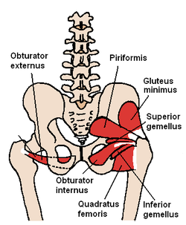
Quick anatomy fact: Piriformis syndrome relates to sciatic nerve pain that starts in the buttocks. Very often patients come to me in my clinic with a suspected disc problem and associated sciatica. Luckily, in many cases, the sciatica (shooting pain down the back of the thigh) is due to a tight piriformis as it lies very close to part of the sciatic nerve and can compress it. As a general rule, if sciatic pain goes down to the knee, it is likely to be muscular-based sciatica, which can involve the piriformis muscle. If the pain goes down to the ankle then it can indicate a problem with the disc.

About me

I am an Advanced Remedial Massage and Manipulative therapist based in Cottingham, Hull and Beverley. I treat a variety of sports people in my clinics and I am always delighted to treat members of the West Hull Ladies running club so if you would like to book an appointment or have any questions, you can email me at kirstieannskelton@hotmail.com, call 07789 914597 or visit my website www.kirstieannskelton.com for further details.

Victoria’s Recipe

Butternut Squash Soup with Chilli


Ingredients
- 1 butternut squash , about 1kg, peeled and deseeded
- 2 tbsp olive oil
- 2 onions , diced
- 1 garlic clove , thinly sliced
- 2 mild red chilies , deseeded and finely chopped
- 850ml hot vegetable stock - from stock cubes and your kettle is fine (I normally use 2 cubes)
- 4 tbsp crème fraîche if you want to add it to soup - plus more to serve

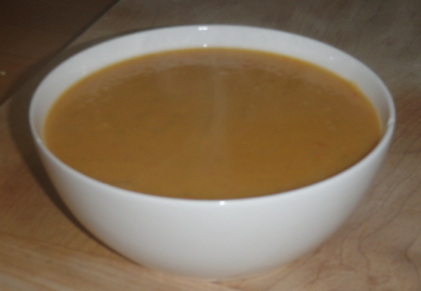
Method:
- Heat oven to 200C/180C fan/gas 6. Cut the squash into large cubes, and then toss in a large roasting tin with half the olive oil. Roast for 30 mins, turning once during cooking, until golden and soft.
- While the squash cooks, put remaining oil in pan and add the onions, garlic and ¾ of the chilli. Cover and cook on a very low heat for approx 15 mins until the onions are completely soft. (be careful they do not burn)
- Tip the squash into the pan, add the stock, give it 5 mins then whizz with a stick blender until smooth – if you don’t have a stick blender put it in a liquidiser and blitz it in batches. Return to the pan, gently reheat, then season to taste. (I never do this bit I just use the stick blender as I don’t have a liquidiser.)
Normally this is the end of production for me as the vultures that are my family are busy serving themselves, however if you wish to present the soup slightly better, serve the soup in bowls with swirls of crème fraîche and a scattering of the remaining chopped chilli.
You can also add some crème fraiche prior to blending, but again I’m normally just trying to get it sorted so don’t usually do this. A word of advice, we like spicy things and I generally add the whole of the 2 chillies and I do normally buy hot ones which does make it spicy, so for a test run perhaps try one chilli. It’s a really easy and healthy soup and the squash makes it have a bit of a sweet flavour, and it will keep for a few days so great to pack up for work or have after a run.
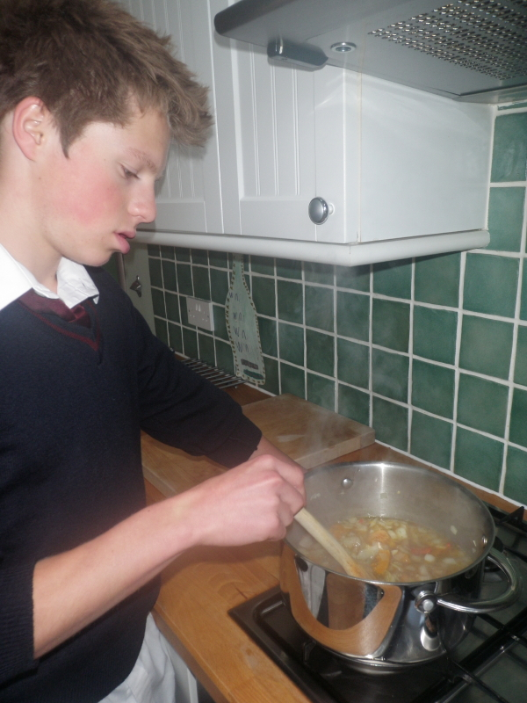
If you are not used to working with butternut squash I find that by cutting it into sections makes it easier to peel and don’t worry if there are a few ‘hairs’ left after you have discarded the pips, just ignore them and wash your hands straight away after handling the squash (due to yellow colour) and chilli (due to colour and spice). And sometimes if I’m rushing I cut up the squash put it in the oven for 30min, put the timer on and just leave it so that when I get home I just need to sort the onion, garlic, chilli and boil a kettle for the stock and shove the squash in. It must be OK as I made it on Tuesday night as an extra and it had vanished before I had a chance to take a photograph, so I made some more on Wednesday night with my son Dominic prior to our run (took some photos this time) – got back home and the ‘vultures’ had demolished it all!!

Tip Top Tips

Bounce Back From Any Setback
The five stages of getting over a bad race experience - and running better next time (from February 2010’s edition of Runners World).

You've trained for months, but race day arrives and something disastrous happens: a bad night's sleep has drained your energy, a freak hailstorm slows you down, a killer cramp forces you to walk. Was it still worth it? Of course it was, if you heed what went wrong.
"A bad race can be a stepping stone to a breakthrough performance," says running coach Mark Wallis (markdwallis.com) "Working through a challenging experience helps you develop mental strength and perseverance." These five post-bad-race stages will help you reset your mindset.

1. Immediately after: WALLOW (A BIT)
"It's natural to be disheartened when things get tough," says Mark O'Hara, author of The Winner's Monologue. Cry, mope, blog, vent to a fellow runner. Do what you need to for a day or two - it'll help you move on. "Just remember why you have such an emotional attachment to the sport," says O'Hara.

2. The morning after: FIND A POSITIVE
Wallis says finding the silver lining will help you get over it. "If you were able to adapt and work through it, consider the race a success," he says. "Focus on something positive that came out of it, whether it's running through a different city or getting a new race T-shirt."

3. A week later: ANALYSE IT
Once your emotions settle, review your training plan, diet and race-day strategy. "Every race is a puzzle," says coach Jeff Horowitz, author of My First 100 Marathons (£15.99, Skyhorse Publishing). "Look for clues to solve it." Did you rest enough during your taper? Did you go out too fast? Did you drink enough leading up to - and during - the race? What went wrong is sometimes within your control.

4. Two weeks later: SET NEW GOALS
Remember that Paula Radcliffe dropped out of the 2004 Olympics, but three months later won the New York City Marathon. If elites allowed themselves to get caught up in a single bad race, they'd be out of work. Adopt this mindset.
"Your running career isn't about one race," says sports psychologist Neal Bowes (simplypg.com). "Use disappointment to fuel your next success." Just make your next goal manageable. If you struggled with mileage, target a shorter distance and set smaller goals along the way. A few 5Ks will calm those butterflies before your next big race.

5. Before your next race: MANAGE EXPECTATIONS
Before you toe the line again, remind yourself that your performance - good or bad - doesn't define you. Running is part of a healthy lifestyle; it can make you feel stronger, happier and saner. Those benefits outshine any post-race glow.

Embrace The Process
Sports psychologist Neal Bowes recommends being process-focused rather than outcome-focused. Here's how to enjoy your journey to the finish line.
Outcome-focused: You focus on a highly ambitious, perhaps unrealistic time goal.
Process-focused: Your time goal is based on training runs and recent races. You also focus on mindset, pacing, fuelling and nutrition.
Outcome-focused: Your confidence as a runner is based on race times. You're driven by how people will view your achievements.
Process-focused: Your confidence is based on your ability to execute a race plan, your development as a runner and the role running plays in your life.
Outcome-focused: Your routine is strict - you train through pain and risk injury.
Process-focused: When you notice a potential sign of trouble, you back off and give your body time to rest.
Outcome-focused: You measure race-day success in terms of times and placing. If you miss a goal time, you feel like a failure.
Process-focused: You measure race-day success partly on times and placing, but also on the experience itself. You learn from mistakes and come back stronger.

Race Write-Ups or Write-Offs

Ferriby 10
Anna: Originally I wasn't going to do Ferriby 10 as I knew that Brass Monkeys was the week before and I thought I would be too tired. But my brother thought it would be a good idea if we did it together (together as in him finishing more then 20 minutes before me....). So I applied a few weeks before the race and only just got in. After Brass Monkeys I was pretty confident. It was "only" 10 miles so shouldn't be too bad. I was told the race was 5 miles up, 2 miles down and 3 miles flat with a HORRIBLE hill at the end. But, I was prepared for this and thought if I could get over the first bit it should be ok. After the first 5 miles I was very tired. Running up hills when you're not used to it is a bit of a shock to the body! But, I thought it’s only another 5, I’m sure I can do it. And I did. I just kept slogging on. Then suddenly I was at the bottom of the big horrible hill ready to run up and finish. I saw Amanda and she gave me the "great!!" news that Gavin had come 5th (If I swore, now would be the time I was doing so). So I ran (struggled) up the hill with the "great!" knowledge that my brother was a prize winning athlete....At the top I saw my brother and used my last precious breath to tell him well done for a great position, in which he replied "5th?! I came 12th!!". And with that, I headed round the corner, smelt food from the pub across the road, started retching into my hand, stumbled across the finish line the slowest I could possibly go whilst belching and concentrating hard on not puking. A first aid man stopped me in the finishing tunnel (which was crawling with happy faces of finishing runners and loads of people watching...) and asked if I was ok, whilst I swayed around wanting to puke all over him. I stood there retching for about 5 minutes looking absolutely ridiculous, got escorted out of the finishing tunnel by the first aid man, rather rudely grabbed my "prize" T-shirt and tried to sip some water. I then watched the other ladies come in, watched Amanda receive first lady in her category (well done!), drove us home (and also drove us into a roundabout...:-S, I blame low blood sugar....), and went to work. I felt sick for most of the day but felt ok the next day. All in all it was a great race, asides from the rather embarrassing end!!
P.S. My brother also had a good time, but feels he could have done better....:-I

Snake Lane
Anna: Having completed Snake Lane 10 I now consume all my beverages in my winner’s drinking vessel. By this I mean the Blue snake lane mug I was given after completing the 10 miles around Pocklington. The mug we were given is awesome! At the end they even let you drink your 20p coffee out of it. If you're thinking of entering Snake Lane 10 I would enter for this reason alone. My cup takes pride position in my kitchen and just looking at the cup makes me feel healthy! Running 10 miles is a great length of race. It’s not quite a half marathon but it’s more challenging than a 10k. It's one of those races you can show off about but not be called "crazy" for running. Snake Lane itself is a very nice route which goes through only one tiny village. This is both good and bad. It's bad because the support was thin on the ground with not many points in which spectators were gathered, but good because it was very pretty! Having ran Ferriby 10 a few weeks before, looking back it's hard to say which one I preferred. Ferriby 10 was very hard and very hilly, but there was more crowd support and the racers seemed to be more riendly, whereas Snake Lane was easier due to less hills but was a bit boring sometimes as there were less supporters and the race pack I got in with were all unwilling to chat. Either way I would definitely do both races again as they were mega fun!
Geri: Travelled to Pocklington with Katy chatting about how she had conned me into doing the race with her. We decided to run together and made a pact to finish the race within two hours and not to finish last. We set off quite steady but by the three mile mark we decided to have a stretch, and then back to the race. I saw a sign for the water and I was like a woman possessed, ended up losing Katy who later assured me that it didn’t matter. I carried on - legs heavy especially running up the final hill - and like a mirage Amanda came trotting up. I tried to tell her that she was running the wrong way but she carried on smiling. And to the finish line finally - what a relief!! So proud of myself and Katy. I came in at 1hour 42mins and Katy 1hour 49mins. Here’s to the Champagne League - bring it on!

Lincoln 10k Vs Hornsea Third Marathon
Anna: Lincoln 10k was a big race for me. I really wanted to win the 10k series and knew that I could do so if I got a time of 50.15 in my 10k in Lincoln, and I thought this was very achievable. I'd been doing lots of training (including horrible fast 5ks on the treadmill - awful but very rewarding and great training!) and I thought I was ready for the race. In comparison for Hornsea third marathon I did a 3.9 mile race on the Tuesday before (Champagne League race) and the week before went to Spain with university on tour (basically spent the whole week drinking too much sangria and eating fried foods...), so not the best training and altogether not ready for the race! Mentally speaking I was very psyched up for Lincoln 10k, whereas I chose to race Hornsea third at the last minute. The actual races themselves were similar and different in many different aspects. Firstly, Lincoln 10k was massive! 5000 entrants ran the 10k and this meant the start was slow, I tripped over people, people failed to put themselves in the right time areas meaning there were delays getting over the line. However, luckily the race was chipped, so although this may have knocked a couple of seconds off my time it was nothing major. I found the worst thing wasn't the thousands of people running the actual race, but the problems with leaving the car park afterwards! Not only did it take ages for the roads to re-open, but 5000 people all trying to get out of one exit took over an hour, which was very frustrating! In comparison Hornsea third marathon was a tiny race with probably closer to a few hundred people running rather than 5000! This meant that we could easily run over the line and people quickly fell into little running groups of roughly the same pace.
Both races were for charity, which I think is great! Charity runs have an awesome atmosphere and it’s great to know that people are running for a worth while cause. I personally ran Lincoln 10k for cancer research in memory of my Uncle Keith who passed away earlier this year. When the race got tough it was a great way to keep going by reminding myself why I was doing the race and how the little bit of pain I was feeling wouldn’t even compare to the amount of pain thousands of cancer patients are feeling each day. Unfortunately due to my late decision to run Hornsea third I didn’t raise any money for their charity (Marie Curie) but saw many people did and thought this was very admirable.
Other differences include the goody bags at the end of the race. This is of critical importance to me. Lincoln 10k cost a lot to enter (I think it was maybe 14 or 15 pounds) whereas Hornsea was only £9 on the day. Therefore I presumed that Lincoln 10k goody bag would be amazing whereas Hornsea would be pretty standard. How wrong was I! At Lincoln 10k the goody bag simply included lots of leaflets advertising races etc... and a medal. No food!! After 10k I was starving! Luckily I had brought a banana so had to eat that...! The medal though is pretty impressive, with a really nice ribbon with pictures and all sorts on it. In comparison the Hornsea goody bag was great! On leaving the finishing tunnel you were presented with a medal around your neck and received a goody bag with a certificate in, a banana (perfect ripeness too!), a chocolate bar and a pencil. Plus lots of leaflets advertising future events, as always. Considering it was so cheap to enter I though the goody bag was fantastic!

To be fair I found I actually struggled in both races. Lincoln 10k was far too hot and I think I started too quickly and found myself struggling the entire way around. I missed my target time by one minute so was fairly disappointed. In Hornsea third I took it steady, but again struggled round feeling sick the entire time (possibly due to a stomach virus I seem to have picked up from my lovely mummy). Never the less, I finished both races, even though I wanted to stop running during both. I think this is a great experience for me. I’ve previously never struggled racing and have always quickly got into a rhythm. I think it’s really good to test your will power and realise that even when times are tough, nothing feels better then finishing the race (whether out of sheer exhaustion or due to a great race time!). When times are tough it’s easy to stop running and give up. It’s times like this that your own will power and own strength drag you round (although great thanks to Karen and Rebecca for dragging me round the entire 8 odd miles on Sunday....!!).
Lincoln 10k and Hornsea third marathon are both great races with many similarities and differences! If I was to choose my favourite I’d have to say Hornsea third, simply because there wasn’t so much congestion, the goody bag was better, it was easier to travel to and much much prettier than Lincoln city streets!
Oh one last thing...during Lincoln 10k I was overtaken by a man running whilst juggling... and also a man running bare footed. I’m still deciding whether this is funny or depressing.... :-)

Hornsea Third Marathon
Amanda: Didn’t I just excel myself with race preparation this time? A fall during a snowboarding class at Xscape left me with a very sore lower back with virtually no running for a week, followed by the actual snowboarding week where I hurt my wrist trying to protect my back then went on to bash my ribs to pieces whilst trying to protect my wrist ..... On arriving home and getting checked out, pretty horrified to find I had broken my wrist quite badly. Even though it really, really hurt when I did it, I assumed it was almost impossible to break your wrist whilst wearing a wrist guard and so it was merely bad bruising and ligament damage and definitely not multiple breaks!
On the Hornsea 1/3 day my battered ribs were more of an issue. I had read that nothing is done about ribs and you just put up with it and get on with life – and so I did. I can’t say they “hurt” whilst running but pulled and tugged and generally felt tight which stopped me “going for it”. When I had finished running they tightened up even more, started to feel a bit like a hunch back!
Despite the aches, it was a lovely day and an enjoyable run and I had plenty left in me at the end so at around 7 miles I pulled past a lady who had been a hundred yards or so ahead of me through the race, she congratulated me at the end which was nice. I was amused at the finish when the chap with the tannoy said “here comes the first in the invalid category” as my arm in a cast was on full display.
After a bit of recovery and chat with runners I jogged back coming across KarenS, Rebecca and Anna who were enjoying each other’s company. Next back passed a lady who was chucking her guts up whilst her “lovely” partner was saying come on, get running – nice eh? Next was Yendis who was looking very strong and finally KarenC whom I ran in with. She was finding it tough and having to dig deep so really impressed with her. Stayed for the presentation, I had come 5th lady and 1st FV50 really pleased with that given the general state of my poor body!
Do I recommend the race? Yes. This is a really nice race, always in aid of Marie Curie and lots of people running for the charity which gives it a non-competitive feel (although we do our best of course). A rural run, fields and greenery. Just one village half way round – Sigglesthorne – where you might get a cheer and the marshals are very supportive. There is a food bar at the end for cups of tea and bacon butties. I recommend this run and think 8.7333333 miles is a really nice distance.

LONDON MARATHON 2011
Hi Ladies, I've been asked to send this information out to all members. As you ladies know Debbie and Antonia have club London Marathon places for this year, and I managed to get a ballot place. Now I’m sure we will all thoroughly enjoy next Sunday and have many tales to tell you all - BUT what I would like to do is explain about ballot places and club places.
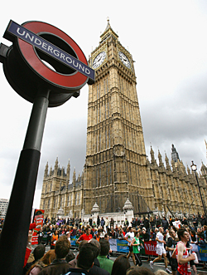
You do not need to raise any money if you have a CLUB or BALLOT place, although you can do if you wish. The alternative to Club and Ballot places is that you get a charity place but the charities do generally dictate a minimum amount that you need to raise in order to get one of their LM places (starting at £1500.00) hence the reason that other places are so popular.
Firstly - anyone can enter the London Marathon via the public ballot, in years gone by this has opened up for entries on-line on the evening of the Marathon (so next Sunday night) I haven't been able to establish that it will be exactly the same this year so I am working on that assumption.
IF YOU WISH TO BE CONSIDERED FOR A CLUB LONDON MARATHON PLACE FOR 2011 - YOU MUST ENTER THE PUBLIC BALLOT. One of the requirements of the club is that if you wish to be considered for club London Marathon places, you must show that you have made an effort to enter yourself and use your rejection slip to enter the club draw (for all club rules about the LM place please look at the club website).
Now here's the encouragement – I’m a plodder, as most of you know I was hit and miss at the club at the beginning of last year due to personal commitments, I don't think I managed a run during the summer (the belly got a lot bigger) and then in September I got myself back out running slowly and got back up to 5/6miles for November.
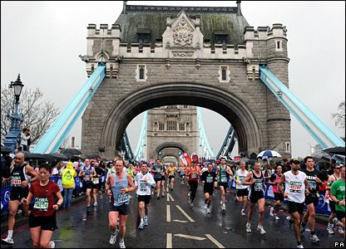
I had entered the ballot after last years LM which I watched my husband run, when I got my acceptance through in October I almost had a fit, I didn't tell people as I had to get myself used to the idea first. Well I decided to go for it and found a beginners programme which when I looked at it I thought - I can do this. AND I have basically worked to it since then.
Everyone is different and I have had a few learning curves through my training and I’m sure Debbie and Antonia have as well (write ups after next weekend to come) but I would like you all to know that whatever your level of running (or plodding as I normally do) you are all capable of running the LONDON MARATHON 2011, whether you want to do it for a time, or just to get round, there are training plans that are achievable for everyone.
I am attaching a copy of the training plan that I have followed which I have basically followed for beginners (and even I could do more than this!) and if for any reason you are thinking - I would like to do this but I’m not sure I can - have a look at the attachment and rest assured EVERYONE can!! And for the newsletter I’m also attaching an intermediate schedule so that you can compare.
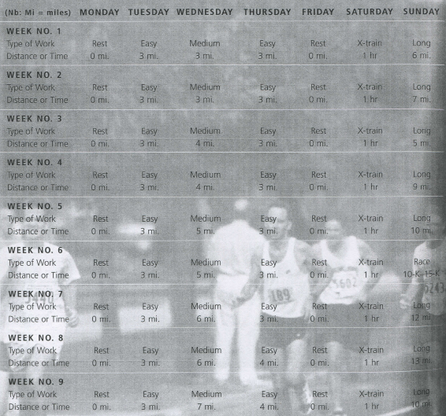
Beginners Schedule (20 – 25 miles per week):

Racing and Running Events

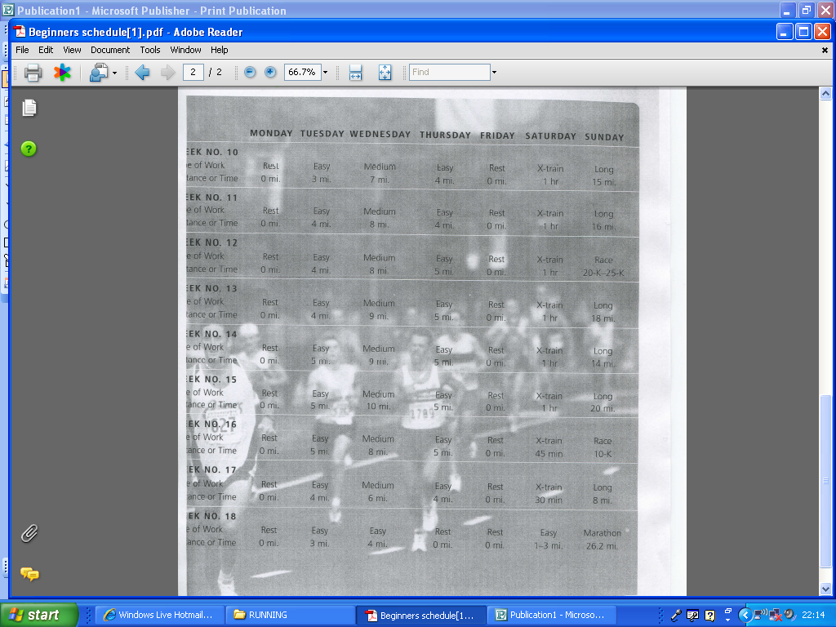

Beginners Schedule (cont’d):

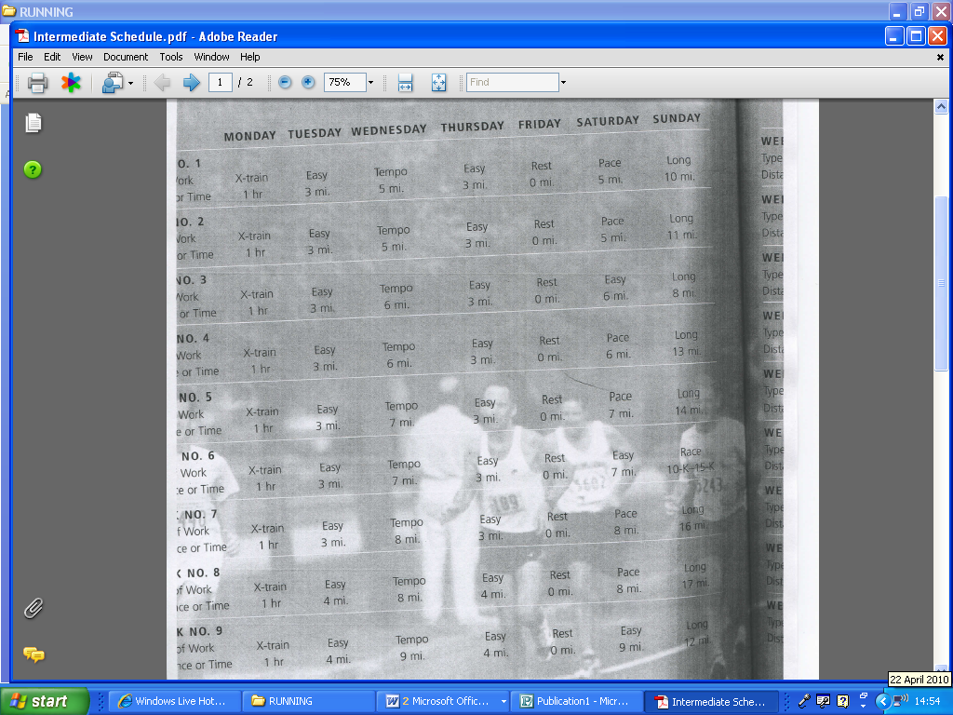
Intermediate Schedule (25 – 30 miles per week):

Intermediate Schedule (cont’d):
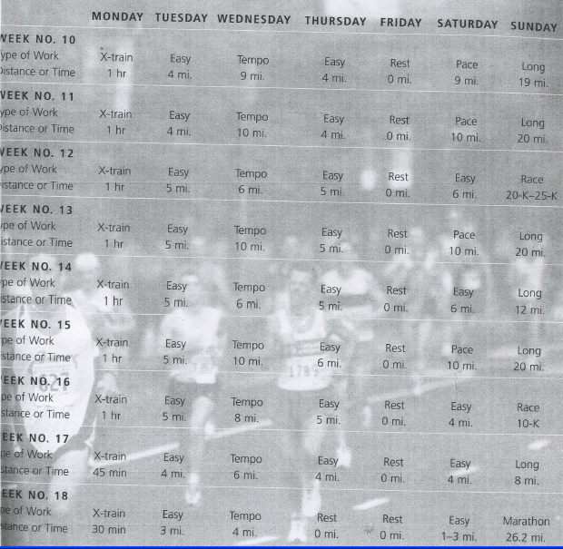

So - if you fancy it - get on-line and enter as soon as possible after next Sunday:

www.virginlondonmarathon.com
And if you don’t get a ballot place, at least you will have a chance of being considered for the club London Marathon Places.
Victoria

2010 Racing and Running Events

Event | Distance | Date | Where | Entry Fee
EHH Summer League Race 1  Beverley 10K  EHH Summer League Race 2  Jane Tomlinson Hull 10K  Mucky Duck 2010 | 5 miles  6.2 miles  6 miles  6.2 miles  8.5 miles | Tuesday 4th May  Sunday 9th May  Tuesday 18th May  Sunday 23rd May  Sunday 30th May | Railway Inn, New Ellerby  @ 7.15pm  Beverley  @ 11.15am  Constable Arms, Sproatley  @ 7.15pm  Hull City Centre  @ 9am  Driffield Rugby Club  @ 11am | League: £16  Race: £3  Club Member - £9  Unattached - £11  League: £16  Race: £3  Club Member - £18  Unattached - £20  Club Member - £8  Unattached - £10
EHH Summer League Race 3  Race For Life  Humber Bridge 10K  Castle Howard Trail 10K  EHH Summer League Race 4  Humber Bridge Half  EHH Summer League Race 5 | 6.2 miles  3.1 miles  6.2 miles  6.2 miles  7 miles  13.1 miles  6.2 miles | Tuesday 1st June  Sunday 6th June  Sunday 6th June  Sunday 13th June  Tuesday 15th June  Sunday 27th June  Tuesday 29th June | Blacksmiths Arms, Coniston  @ 7.15pm  Costello Stadium  @ 11am  Hessle Rugby Club  @ 11am  Castle Howard  @ 11.15am  Constable Arms, Sproatley  @ 7.15pm  Humber Bridge  @ 10.30am  Sports Club, Leven  @ 7.15pm | League: £16  Race: £3  £12.99  Club Member - £9  Unattached - £11  Club Member - £8  Unattached - £10  League: £16  Race: £3  Club Member - £18  Unattached - £20  League: £16  Race: £3
Withernsea 5  Walkington 10K  EHH Summer League Race 6  Laxton 10K  EHH Summer League Race 7 | 5 miles  6.2 miles  6.2 miles  6.2 miles  4 miles | Sunday 4th July  Friday 9th July  Tuesday 13th July  Wednesday 14th July  Tuesday 27th July | To follow…  Walkington  @ 7.30pm  Sports Club, Leven  @ 7.15pm  Laxton  @ 7pm  East Park  @ 7.15pm | To follow…  Club Member - £9  Unattached - £11  League: £16  Race: £3  Club Member - £8  Unattached - £10  League: £16  Race: £3

** Dates/times are subject to change **
If you want any further information about these races, races out of this region or know of any races not mentioned above please get in touch via West Hull Ladies e-mail and mark your e-mails for the attention of ‘Karen S’.
Please let me know if you have/are going to enter a race as it may give others that little bit of encouragement to get signed up. You will find the Race File in the changing area which has a section for you to let us know what races you are signing up for. Give training purpose…sign up for a race, train regular with the club and this will help you to stay motivated as a West Hull Ladies runner.

Karen S, Racing Officer

NOTE: Club Vests must be worn at any races you enter under the West Hull Ladies running club name

Clubwear prices

Vest - £15.00
T- shirt - £16.50
Hoodie - £14.00
Jacket - £24.50

All the above are ordered on request and must be paid for at time of ordering. To place an order please get in touch via West Hull Ladies e-mail and mark your e-mails for the attention of Victoria.

Running Library

Using the library:Locker 18. Chose your book, write your name and date on the card and leave the card in the locker so we know where the book is.

Book List
The Runner's Diet (Runners World), Madelyn H. Fernstrom
Paula My Story so Far, Paula Radcliffe
Running Made Easy, Susie Whalley
The Complete Book of Running for Women, Claire Kowalchik
Absolute Beginner's Guide to Half Marathon Training, Heather Hedrick
Run Fast: How to Beat your Best Times Everytime, Hal Higdon
The Runner's Handbook, Bob Glover
The Competitive Runner's Handbook, Bob Glover & Shelly Lynn Glover
Marathon: From Start to Finish, Sam Murphy
Marathon Running for Mortals, John Bingham
4 Months to a 4 Hour Marathon, Dave Kuehls
Marathon Running Beginner to Elite, Richard Nerurka

Running Magazines available to borrow from the table in the club room

